41891 / 42891 Cloud Computing Infrastructures
Assignment 1 — Spring 2026
Field | Detail
Student name | [insert your name]
Student ID | [insert your student ID]
Subject | 42891 Infrastructure for Cloud Computing
Assessment | Assignment 1 (individual), weighting 20%
Due | 17:00 Friday 28 August 2026
Word count | approximately 7,700 words excluding the reference list

This report answers the eight assignment questions. Each answer is grounded in the Week 1–3 subject lecture material and extended with independent research, using Harvard in-text citations throughout; full details appear in the reference list. Six original diagrams are provided where a visual answer is clearer than prose.

Question 1 (5 points)
What is cloud? What is cloud computing? Explain the cloud cost model.

1.1 What is a cloud? (2 points)
A cloud is a pool of virtualised computer resources — compute, storage, network and the software that binds them — that is able to host a variety of different workloads and to provision hardware, software and data sets dynamically on demand (Zhang 2026a). Three properties distinguish a cloud from an ordinary server room:
- Pooling. Physical resources are aggregated and abstracted, so a consumer is served from a shared pool rather than from an identified machine (Mell & Grance 2011).
- Multi-workload hosting. The same pool simultaneously carries unrelated and heterogeneous workloads belonging to different tenants.
- Dynamic, on-demand provisioning. Capacity is allocated and released programmatically in minutes rather than through a procurement cycle.
It is worth separating two senses of the word that are often conflated. The noun 'cloud' names the resource pool and the delivery infrastructure that fronts it; 'cloud computing' names the service and utilisation model by which that pool is consumed (Erl, Puttini & Mahmood 2013). A virtualised data centre that is never offered as a metered, self-service resource is a cloud in the first sense but is not doing cloud computing in the second.

1.2 What is cloud computing? (1 point)
The standard definition is that of the US National Institute of Standards and Technology:
"Cloud computing is a model for enabling ubiquitous, convenient, on-demand network access to a shared pool of configurable computing resources (e.g., networks, servers, storage, applications and services) that can be rapidly provisioned and released with minimal management effort or service provider interaction" (Mell & Grance 2011, p. 2).
NIST decomposes the model into five essential characteristics — on-demand self-service, broad network access, resource pooling, rapid elasticity and measured service — three service models and four deployment models (Mell & Grance 2011). Erl, Puttini and Mahmood (2013, p. 27) offer a complementary, more technical framing: cloud computing is "a specialized form of distributed computing that introduces utilization models for remotely provisioning scalable and measurable resources". Read together, the two definitions capture both halves of the concept: NIST emphasises the consumption experience, Erl emphasises the underlying distributed-systems mechanics. The recurring element in both is measurement — without metering there is no pay-per-use, and without pay-per-use the cost model below collapses back to the traditional one.

1.3 The cloud cost model (2 points)
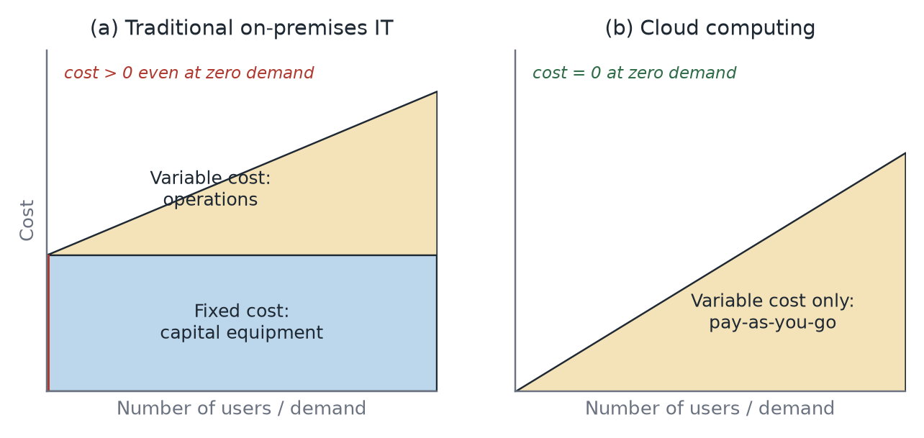
Figure 1. The cloud cost model. Traditional IT carries a fixed capital cost that is incurred before any demand arrives; cloud computing converts that block into a variable operational cost proportional to consumption. Adapted from Zhang (2026a).
The essential difference is the shape of the cost curve, not merely its height. In the traditional model an organisation buys and owns hardware, system software and licences sized for peak demand, then installs, configures, tests and manages it (Zhang 2026a). This produces a large fixed capital cost that is paid up front regardless of utilisation, plus a variable operational cost on top. In the cloud model the consumer subscribes and pays for what is actually used, priced against a quality-of-service level, so the fixed block disappears and total cost becomes an essentially variable function of demand.
Three consequences follow, and they are the reason the model matters commercially rather than just arithmetically:
- Capex becomes opex. Expenditure moves from the balance sheet to the operating budget, which lowers the barrier to starting a project and removes the write-off risk of buying the wrong capacity.
- Over- and under-provisioning risk transfers to the provider. Armbrust et al. (2010) note that fixed provisioning must be sized either for the peak, wasting capacity most of the time, or below the peak, in which case rejected demand represents lost revenue that can exceed the hardware saving. Elasticity removes the need to choose.
- Economies of scale are shared. Providers buy power, hardware and bandwidth at volumes an individual enterprise cannot match, and the subject material cites total-cost savings in the order of 80–95% against buy-and-own for suitable workloads (Zhang 2026a).
The model is not universally cheaper. A steady, fully-utilised, long-lived workload has no elasticity to exploit, and paying a per-hour margin indefinitely on capacity that never varies can exceed the amortised cost of owned hardware. Marston et al. (2011) accordingly frame the decision as one of demand variability and time horizon rather than unit price: the cloud cost model pays for itself where demand is uncertain, spiky or short-lived, and is weakest where it is flat and predictable.

Question 2 (15 points)
What are the cloud service models? Describe IaaS, PaaS and SaaS and the relationships among them.

2.1 The cloud service models (3 points)
NIST defines three service models, distinguished by how much of the technology stack the provider operates on the consumer's behalf (Mell & Grance 2011):
- Infrastructure as a Service (IaaS) — the provider supplies processing, storage, networks and other fundamental computing resources; the consumer deploys and runs arbitrary software, including operating systems.
- Platform as a Service (PaaS) — the consumer deploys applications written in supported languages onto a provider-managed platform, without managing the underlying servers, operating systems or storage.
- Software as a Service (SaaS) — the consumer uses the provider's applications running on cloud infrastructure, controlling only limited user-specific configuration.
An important distinction: the deployment models — public, private, community and hybrid — form a separate, orthogonal axis (Mell & Grance 2011; Zhang 2026a). Any of the three service models can be delivered under any of the four deployment models, and the two should not be presented as a single list. Beyond the core three, ISO/IEC (2014) formalises further cloud service categories including Communications as a Service, Network as a Service and Data Storage as a Service; these are treated as siblings of the core three rather than as additional layers, and Network as a Service is discussed in Question 7.

2.2 The three models and the relationships among them (12 points)
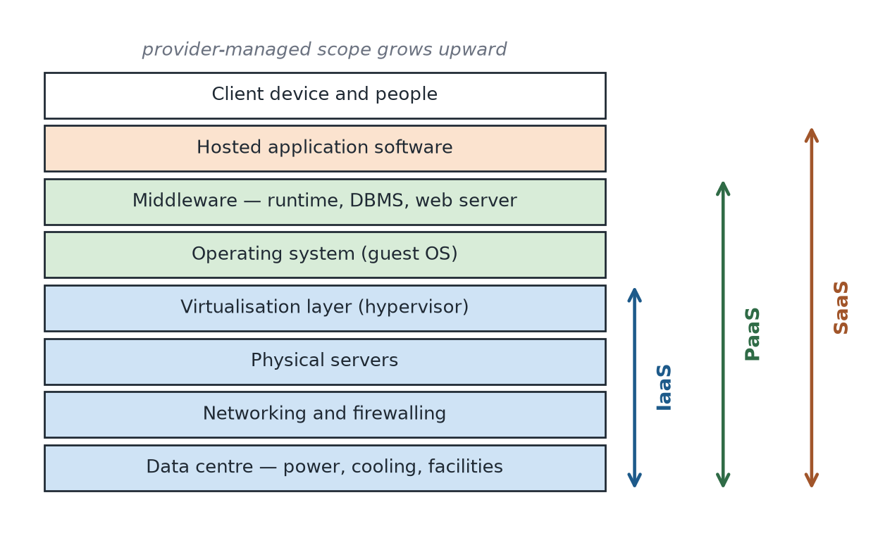
Figure 2. Service-layer view of IaaS, PaaS and SaaS. Each bracket shows how far up the stack the provider's responsibility extends; everything above the bracket remains the consumer's responsibility. Adapted from Zhang (2026a).
Figure 2 is the clearest way to state the relationships, because all three models describe the same stack of layers and differ only in where the line of responsibility is drawn.

Infrastructure as a Service
IaaS delivers a virtual server, virtual storage and virtual networking, and stops there. The consumer receives a machine and is responsible for the guest operating system upward: patching, middleware, runtime, application code and data. The commercial relationship is expressed as a contract over infrastructure characteristics — the subject material gives the example of a virtual server with 32 GB RAM and 4 GB local storage, an SLA of 99.5% availability with no failover, priced at $0.95 per hour plus $0.05 per GB transferred out of the cloud (Zhang 2026b). IaaS offers the most control and demands the most operational effort. Amazon EC2, Azure Virtual Machines and Google Compute Engine are the canonical examples.

Platform as a Service
PaaS delivers a ready-made environment: the operating system, runtime, application server and often a managed database are already installed, configured and maintained. The consumer supplies only the application and its configuration. Erl, Puttini and Mahmood's PaaS illustration marks the layer below the environment with a question mark, indicating that the consumer is deliberately shielded from the implementation details — the consumer cannot generally know or control which physical host, or how many, is serving the workload (Zhang 2026b). That concealment is the point rather than a limitation: it is what permits the provider to auto-scale and patch beneath a running application. A representative contract is an application server plus DBMS platform with 99.5% availability and auto-scaling at $0.45 per hour per 500,000 requests (Zhang 2026b). Examples include AWS Elastic Beanstalk, Azure App Service and Google App Engine.

Software as a Service
SaaS delivers a finished application over the network. The consumer accesses the service through its published interface and the contract only — for example a response-time SLA of 0.5 ms at $0.05 per 100 requests — with no access to the underlying IT resources or implementation (Zhang 2026b). Control is limited to tenant-level configuration: users, roles, branding, workflow settings. Salesforce, Microsoft 365 and Google Workspace are typical.

How the three relate
Four relationships matter, and a complete answer needs all four rather than only the first.
- Layered containment. Each model encompasses the layers of the model below it: PaaS is built on infrastructure equivalent to IaaS, and SaaS is built on a platform equivalent to PaaS. Provisioning of physical and virtualised resources at the IaaS layer therefore underpins everything above it (Zhang 2026a).
- An inverse trade-off between control and management burden. Moving up the stack, the consumer surrenders control and gains freedom from operations; moving down, the consumer regains control and reacquires the work. There is no model that is simply 'better' — the choice is which layer of the stack the organisation wants to be responsible for.
- Progressive abstraction. Each step upward hides more implementation detail, which is what enables the provider to change, scale and repair the layers beneath without consumer involvement. The hiding is also the source of the models' main weakness: what is invisible cannot be tuned, audited directly, or easily migrated elsewhere.
- Logical, not physical, dependency. The stacking is a description of responsibility boundaries, not of corporate structure. A SaaS provider may build on a third party's IaaS, or may own and operate its own data centres and expose nothing below the application. Likewise a consumer may combine models — running a SaaS product for email, a PaaS platform for a customer portal, and IaaS instances for a legacy application, all at once.
Table 2. Responsibility boundaries and trade-offs across the three service models.
Aspect | IaaS | PaaS | SaaS
Consumer controls | Guest OS, middleware, runtime, application, data | Application and its configuration, application data | User-level configuration only
Provider manages | Virtualisation, servers, storage, networking, facility | All of IaaS plus OS, runtime, middleware, scaling | The entire stack including the application
Unit of delivery | Virtual machine, volume, virtual network | Ready-made execution environment | Working application / API
SLA expressed as | Availability and capacity of the instance | Availability plus platform behaviour such as auto-scaling | Application response time and availability
Main benefit | Maximum control and workload portability | Fastest path from code to production | No operations burden at all
Main limitation | Consumer still runs an operating system estate | Constrained to supported languages and services | Least configurability; strongest lock-in

Question 3 (15 points)
What are the cloud components? Describe the cloud architecture based on these components.

3.1 The cloud components (5 points)
At the level of the infrastructure that actually serves workloads, a typical cloud is built from five components (Zhang 2026b):
Table 3. The five infrastructure components of a typical cloud (after Zhang 2026b).
Component | Role in the cloud
Virtual machines | Isolated instances of a guest operating system and its applications that behave like separate computers; each encapsulates its virtual hardware, virtual disks and metadata, which is what makes it copyable and movable.
Hypervisor | The virtualisation layer that creates the VMs, allocates physical resources to them, isolates them from one another and participates in moving them between hosts.
Physical servers | The compute substrate — commonly x86 rack or blade servers, aggregated into clusters so that capacity is addressed as a pool rather than as individual machines.
Networks | Physical switching and routing plus the virtual switches and port groups that connect VMs to each other, to storage and to the Internet.
SAN storage | Shared block-level storage reached over a dedicated fabric, which allows several hosts to see the same datastore — the precondition for live migration and high availability.

A second, broader taxonomy describes the technology innovations a provider must assemble to offer cloud services at all: broadband networks and Internet architecture, data centre technology, virtualisation technology, web technology, multitenant technology and service technology (Zhang 2026c; Erl, Puttini & Mahmood 2013). The two lists are complementary — the first enumerates what sits in the rack, the second the technology families that make the rack sellable as a service.

3.2 The cloud architecture built from these components (10 points)
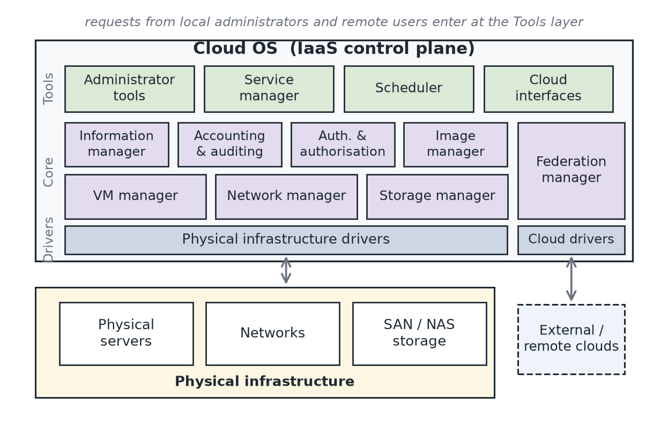
Figure 3. IaaS cloud architecture. The Cloud OS sits between users and the physical infrastructure, organised into a Tools layer, a Core layer of managers, and a Drivers layer that abstracts specific hardware and remote clouds. Adapted from Zhang (2026a).
The components of Section 3.1 are inert on their own. What turns them into a cloud is a control plane — a 'Cloud OS' — that manages them collectively. The analogy with a conventional operating system is exact in three respects: both manage CPU, memory, disk and I/O; both provide a secure, isolated multi-tenant execution environment for user workloads; and both abstract the user away from the specifics of the underlying hardware behind interfaces and APIs (Zhang 2026a). The difference is scale — the unit of scheduling is a virtual machine on a cluster rather than a thread on a chip.
The architecture in Figure 3 is organised into four horizontal layers.

Physical infrastructure layer
Servers, networks and storage arrays: the raw capacity described in Section 3.1. Nothing here is cloud-specific, which is the intent — the layers above are designed to make commodity hardware interchangeable.

Drivers layer
Physical infrastructure drivers translate the Core layer's generic instructions into vendor-specific operations against a particular hypervisor, switch or storage array. Cloud drivers do the same for external clouds, allowing the local installation to treat a remote provider as another source of capacity. This layer is what keeps the architecture portable: replacing a storage vendor changes a driver, not the managers above it.

Core layer
Eight managers implement the actual cloud functions (Zhang 2026a):
Table 4. Core-layer managers of the Cloud OS and their responsibilities.
Manager | Responsibility
VM manager | Manages a VM's entire life cycle and performs VM actions — deploy, migrate, suspend, resume, shut down — according to user demand or scheduling strategy.
Network manager | Manages private networks that interconnect a service's internal components, manages public IP address pools, and connects front-end components to the Internet.
Storage manager | Provides storage services and end-user virtual storage systems as a commodity.
Image manager | Handles a large population of VM images belonging to different users with different operating systems and software configurations.
Information manager | Monitors and gathers state information about VMs, physical servers, network devices and storage systems.
Accounting and auditing | Obtains and records resource-usage information for deployed services — the metering that makes 'measured service' possible.
Authentication and authorisation | Authenticates users and administrators and grants access only to authorised resources.
Federation manager | Enables access to remote cloud infrastructures, supporting hybrid and cloud-bursting patterns.

Tools layer
Administrator tools cover user management and physical-infrastructure management. The service manager manages and supports virtualised multi-tier services. Cloud interfaces expose the provider's APIs — and because most products and providers offer their own APIs rather than a common one (Zhang 2026a), this layer is where vendor lock-in is concentrated. The scheduler operates at three distinct levels, which is worth stating explicitly because the levels are often conflated:
- Physical host level, managed by the hypervisor scheduler: deciding when VMs obtain system resources, and which physical CPUs are assigned to each VM.
- Cloud level, managed by the Cloud OS scheduler: deciding the particular physical server on which each VM is deployed.
- Federation level: deciding to deploy a VM in a remote cloud when insufficient resources are available locally.

How a request flows through the architecture
Tracing a single request ties the layers together. A consumer calls the cloud interface to request a virtual server. Authentication and authorisation validate the caller and the entitlement. The scheduler selects a physical host with sufficient free capacity — or, if none exists, hands the request to the federation manager for placement in a remote cloud. The image manager supplies the requested VM image; the storage manager provisions a volume from the shared pool; the network manager attaches the VM to the appropriate private network and, if needed, allocates a public IP. The VM manager instructs the physical infrastructure driver, which commands the hypervisor on the chosen host to instantiate the machine. From that point the information manager monitors its state and the accounting subsystem meters its consumption so that it can be billed. Every component in Section 3.1 is touched, and each is reached only through the manager that owns it — which is what makes the architecture substitutable at the hardware level.
At a finer grain, Erl, Puttini and Mahmood (2013) describe the reusable mechanisms that implement these functions — logical network perimeter, virtual server, cloud storage device, cloud usage monitor, resource replication and ready-made environment on the infrastructure side, and remote administration, resource management, SLA management and billing management on the management side (Zhang 2026c). Combining them yields the fundamental cloud architectures of workload distribution, resource pooling, dynamic scalability and service load balancing.

Question 4 (20 points)
What is virtualisation? Describe the different layers of virtualisation. What is a hypervisor, and what does it do?

4.1 What is virtualisation? (5 points)
Virtualisation is the abstraction of computer resources: the insertion of a software layer that presents logical resources to consumers while hiding, aggregating or subdividing the physical resources beneath. Its goal is to use IT resources collaboratively to the maximum level and so to reduce their cost (Zhang 2026b). Structurally, virtualisation replaces the arrangement in which a single operating system owns all hardware with one in which a new software layer — the virtual machine monitor — lets multiple operating systems share the same hardware (Zhang 2026b).
The classical formal treatment is that of Popek and Goldberg (1974), who specify three properties a virtual machine monitor must satisfy: equivalence (a program running under the VMM behaves as it would on bare hardware), resource control (the VMM retains complete control of virtualised resources) and efficiency (a statistically dominant subset of instructions executes directly on the processor without VMM intervention). These criteria still explain modern design decisions. The x86 architecture was not originally virtualisable in Popek and Goldberg's sense, which is why early solutions used binary translation or paravirtualisation (Barham et al. 2003) before Intel VT-x and AMD-V added the hardware support that makes efficient virtualisation routine today.
The business case follows directly from consolidation. A physical server dedicated to one application typically runs at low utilisation; virtualising several such workloads onto one host raises utilisation and reduces server count, floor space, power and cooling. Equally important, encapsulating a machine as a set of files makes it copyable, movable and restorable — capabilities that underpin the elasticity, replication and high-availability behaviours described elsewhere in this report.

4.2 The layers of virtualisation (5 points)
Two complementary taxonomies are useful. The first classifies virtualisation by the resource being abstracted (Zhang 2026b; Erl, Puttini & Mahmood 2013):
Table 5. Virtualisation classified by the resource abstracted.
Type | What is abstracted
Processor virtualisation | Enables a processor to be shared across multiple application instances; each VM is presented with logical CPUs that the hypervisor schedules onto physical cores.
Memory virtualisation | Aggregates memory resources into a single pool and manages that memory on behalf of the multiple applications using it, mapping guest-physical to host-physical addresses.
Network virtualisation | Entails virtual IP management and segmentation — virtual switches, port groups and VLANs — so that physical routers and switches are abstracted into logical network fabrics.
Storage virtualisation | Provides a layer of abstraction for the physical storage of data, presenting physical arrays as a single logical pool (see Question 5).
Power virtualisation | A physical UPS can be abstracted into a virtual UPS, extending the abstraction to facility infrastructure.

The second taxonomy classifies virtualisation by where in the software stack the abstraction is inserted, which explains why different technologies have different isolation and overhead characteristics:
- Hardware / platform level. A hypervisor virtualises the machine itself, so each guest runs its own kernel. Implemented by full virtualisation with binary translation, by paravirtualisation in which the guest is modified to call the hypervisor directly (Barham et al. 2003), or by hardware-assisted virtualisation using Intel VT-x or AMD-V. Strongest isolation, highest per-instance overhead.
- Operating-system level. A single kernel presents multiple isolated user-space instances — containers. Very low overhead and fast start-up, but all instances share one kernel, so isolation is weaker and the guest OS cannot differ from the host kernel.
- Application level. A managed runtime such as the JVM or .NET CLR virtualises the execution environment for a single application, giving portability across operating systems without virtualising the machine.
- Desktop and presentation level. VDI and published-application technologies decouple the user interface from the machine executing it.

4.3 What is a hypervisor? (5 points)
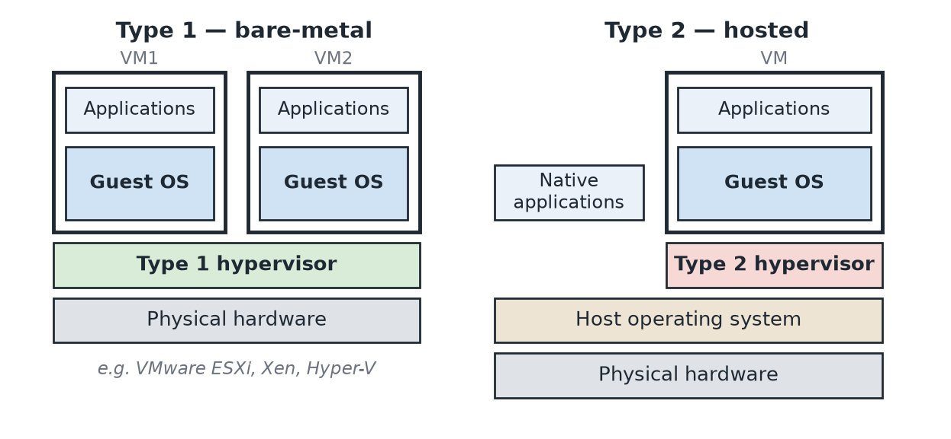
Figure 4. Type 1 (bare-metal) and Type 2 (hosted) hypervisors. A Type 1 hypervisor runs directly on the hardware; a Type 2 hypervisor runs as an application above a host operating system. Adapted from Zhang (2026b).
A hypervisor, also called a virtual machine monitor, is the software layer responsible for managing the applications' operating systems — the guest OSs — and their use of system resources such as CPU, memory and storage. It supports isolation between, and manages, multiple VMs running on the same host computer, and it provides each VM with logical CPU and memory, logical storage blocks and logical network resources (Zhang 2026b). The virtual machine it produces is an isolated instance of application software and a guest operating system that runs like a separate computer, encapsulating its virtual hardware, virtual disks and associated metadata (Zhang 2026b).
Hypervisors fall into two types. A Type 1 or bare-metal hypervisor — VMware ESXi, Xen, Microsoft Hyper-V — installs directly onto the hardware with no host operating system beneath it. Because no general-purpose OS sits in the I/O path, overhead is lower and the trusted computing base is smaller, which is why Type 1 is the production choice in data centres. A Type 2 or hosted hypervisor — VMware Workstation, Oracle VirtualBox — runs as an ordinary application on a host operating system alongside native applications. It is convenient for desktops, development and teaching, at the cost of an extra scheduling and I/O layer.
The distinction is observable in the subject's own laboratory environment. In the Week 2 laboratory ESXi is installed onto a virtual machine with 2 vCPUs, 4 GB RAM and an 18 GB disk as a local, bare-metal install with no underlying operating system (Zhang 2026d) — the defining characteristic of Type 1. Because that installation is nested inside VMware Workstation, a Type 2 hypervisor, the host must expose hardware virtualisation extensions to the guest before the inner ESXi can run VMs at all. That requirement is direct practical evidence that a Type 1 hypervisor depends on CPU virtualisation extensions rather than on services from a host OS, since there is no host OS to provide them.

4.4 What does a hypervisor do? (5 points)
The hypervisor performs four principal functions (Zhang 2026b), each of which decomposes into concrete mechanisms:
- Creating and managing VMs. The hypervisor instantiates virtual hardware from a configuration and image, and drives the VM through its life cycle — power on and off, suspend, resume, snapshot, clone. This is what makes a machine into a file, and a file into a machine.
- Allocating 'hardware resources' to VMs from the virtualised pool of hardware resources belonging to the physical server. The hypervisor time-slices physical cores among virtual CPUs, maps guest-physical to host-physical memory (using nested paging such as Intel EPT, or shadow page tables where hardware support is absent), reclaims memory through ballooning and page sharing, and presents storage and network devices either by emulating real hardware or through paravirtual drivers. Allocation is policy-driven: in the Week 6 laboratory, resource pools with different share values and a 500 MHz CPU limit produce measurably different execution times for the same CPU-bound script running in two VMs on one host (Zhang 2026e), which is resource control made visible.
- Monitoring the status of the VMs. The hypervisor is the only component positioned to observe actual consumption per VM, and it supplies the data that the Cloud OS information manager and the accounting subsystem depend on (see Question 3).
- Taking part in the movement of VMs from one system to another. Live migration works by copying memory pages to the destination host while the VM continues to run, iteratively re-copying pages dirtied during the copy, then briefly quiescing the VM to transfer the final state and CPU registers before resuming it on the destination (VMware 2011). VMware vMotion moves live, running virtual machines from one host to another while maintaining continuous service availability (Zhang 2026c). The Week 4 laboratory performs exactly this migration between ESXi01 and ESXi02 (Zhang 2026f).
Underlying all four is the property that gives the hypervisor its name: it holds a higher privilege level than any guest kernel, so it can trap and mediate privileged instructions. That mediation is simultaneously the source of its power and the reason the hypervisor is the most security-critical component in the stack — a compromise of it defeats the isolation of every VM above it.

Question 5 (15 points)
What is storage virtualisation, what does it do, when should it be used? What is a SAN and what does it do?

5.1 What is storage virtualisation? (2 points)
Storage virtualisation is:
"the process of presenting a logical view of the physical storage resources to a host computer system, treating all storage media (hard disk, optical disk, tape, etc.) in the enterprise as a single pool of storage" (Zhang 2026b).
In other words, it is the storage-specific case of the general abstraction described in Question 4: hosts address logical capacity, and a mapping layer translates that to physical extents on real media.

5.2 What does storage virtualisation do? (5 points)
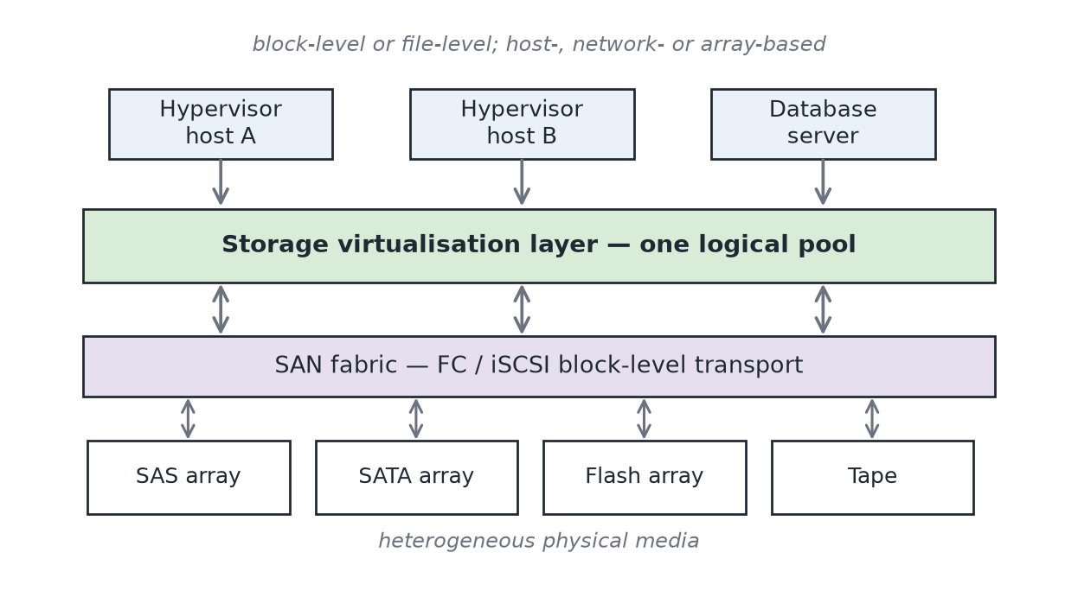
Figure 5. Storage virtualisation presents heterogeneous physical media to hosts as a single logical pool. The layer may be implemented in the host, in the network or in the array.
The subject material classifies storage virtualisation along two dimensions (Zhang 2026b). By granularity there are two types — block-level virtualisation, which abstracts raw blocks and LUNs, and file-level virtualisation, which abstracts a file system namespace. By placement there are three methods — network-based, in which an appliance or switch in the fabric performs the mapping; host-based, in which a volume manager or the hypervisor does so; and array-based, in which the storage controller itself presents virtual volumes.
Functionally, the layer performs the following work:
- Pooling and abstraction. It hides and manages the complexity and differences among physical storage subsystems, so that a host need not know the vendor, protocol or geometry of the media serving it (VMware 2009).
- Presentation as local devices. To applications and guest operating systems inside each VM, storage appears as SCSI disks connected to a virtual host bus adapter, with virtual SCSI disks provisioned from datastore elements in the data centre (VMware 2009). The guest is unaware that its disk is a file on a shared array.
- Capacity efficiency. Thin provisioning allocates physical capacity on write rather than on creation; deduplication and compression reduce the physical footprint of similar data.
- Non-disruptive data mobility. Because the host addresses a logical volume, the mapping beneath can be changed while I/O continues, allowing migration between arrays or tiers without downtime.
- Data services. Snapshots, clones, replication and automated tiering are implemented once at the virtualisation layer and apply uniformly across heterogeneous back-end hardware (Tate et al. 2018).
Different access styles coexist above the same abstraction: block access via iSCSI, Fibre Channel or FCoE LUNs; file access via POSIX interfaces such as NFS and CIFS; object access through HTTP CRUD operations; and dataset access through a DBMS API (Zhang 2026c). In VMware terms, datastores formatted with VMFS or presented over NFS sit above DAS SCSI, FC SAN, iSCSI and NAS hardware without the VMs above them being aware of the difference (Zhang 2026b).

5.3 When should storage virtualisation be used? (3 points)
The subject material defines the technology but does not state selection criteria, so this section draws on industry practice and vendor documentation. Storage virtualisation is justified when one or more of the following conditions holds:
- Multiple hosts must access the same data. Live migration, high-availability clustering and fault tolerance all require that the destination host can reach the source VM's disks. Shared, virtualised storage is a precondition rather than an optimisation (VMware 2011).
- The estate is heterogeneous. Where arrays from different vendors or generations coexist, a virtualisation layer gives one management model, one set of data services and one pool of capacity instead of several islands (Tate et al. 2018).
- Utilisation is low and fragmented. Capacity stranded in per-server islands cannot be reassigned; pooling plus thin provisioning recovers it. This is the storage analogue of server consolidation.
- Hardware refresh must be non-disruptive. Organisations with continuous-availability requirements need to move data between arrays without application downtime, which the abstraction layer makes routine.
- Multi-tenancy or chargeback is required. Carving a pool into logical volumes per tenant, with quotas and measured consumption, is far simpler than allocating physical spindles.
It should not be used indiscriminately. For a latency-critical workload confined to a single host, direct-attached storage avoids both a network hop and a mapping layer. For small estates the licensing, complexity and additional failure domain introduced by the abstraction layer can exceed its benefit, and an in-band virtualisation appliance that is not itself made redundant becomes a single point of failure for every host behind it. The decision is therefore driven by sharing requirements, estate heterogeneity and availability targets rather than by capacity alone.

5.4 What is a SAN? (2 points)
A Storage Area Network is a dedicated high-speed network that connects servers to shared, consolidated block-level storage pools through a SAN switch fabric, commonly over Fibre Channel optics or over IP using iSCSI (Zhang 2026b; Tate et al. 2018). It is one of the three standard storage topologies, and the contrast with the other two is the clearest way to define it:
Table 6. DAS, NAS and SAN compared (after Zhang 2026b).
 | DAS | NAS | SAN
Connection | Directly attached to one server via a host bus adapter | Attached to the general-purpose LAN via an Ethernet switch | Attached via a dedicated storage fabric (FC or iSCSI)
Access granularity | Block | File (NFS, CIFS) | Block (LUNs)
Sharing | None — captive to its host | File-level sharing among many clients | The same LUNs presented to multiple hosts
Typical use | Local boot, scratch, small servers | File shares, home directories, some VM datastores | Databases, mail servers, hypervisor datastores

5.5 What does a SAN do? (3 points)
A SAN performs three things that a directly attached disk cannot.
- It decouples storage from the server. Capacity lives in shared pools and is presented to whichever hosts need it, so a database server, a mail server and a group of hypervisors can all draw from the same infrastructure (Zhang 2026b). Capacity can be grown or reassigned without opening a server.
- It transports block I/O with the semantics of a local disk. Remote LUNs appear to the operating system as ordinary SCSI devices, so file systems and databases that require block access — and cannot run correctly over a file-sharing protocol — work unmodified. Multipathing across redundant fabrics provides resilience and load balancing, while zoning and LUN masking control which host may see which volume (Tate et al. 2018).
- It enables the cluster-level capabilities that define a virtualised data centre. Because several hypervisors can mount the same datastore concurrently, a VM's files remain reachable when it moves, which is what makes live migration and automatic restart after host failure possible.
The third point was demonstrated directly in the laboratory sequence. In the Week 3 laboratory an iSCSI target at 172.20.20.50 is added as a dynamic target on the software iSCSI adapter of both ESXi01 and ESXi02, after which the same FreeNAS iSCSI device appears on both hosts and a shared VMFS datastore is created on it (Zhang 2026g). The Week 4 laboratory then depends on that shared storage: hosts must be verified as still connected to the iSCSI target from the previous week before VM migration between them is attempted (Zhang 2026f). The sequence makes the dependency concrete — storage virtualisation over a SAN is not merely a convenience for capacity management, it is the enabling condition for workload mobility, and therefore for the elasticity and availability properties that the rest of the cloud model assumes.

Question 6 (10 points)
Explain at least five challenges in building an IaaS platform and how you can deal with them.
Building an IaaS platform is harder than assembling its components, because the platform must deliver isolation, elasticity and measured service simultaneously and continuously. Seven substantial challenges are set out below with concrete mitigations; the first five are the most commonly cited in the literature (Zhang, Cheng & Boutaba 2010; Buyya et al. 2009).
Table 7. Seven challenges in building an IaaS platform and their mitigations.
Challenge | Why it is difficult | How to deal with it
1. Multi-tenant isolation and security | Tenants share physical hosts, fabrics and arrays. Ristenpart et al. (2009) showed that an attacker can place a VM on the same physical machine as a target and extract information through side channels; the hypervisor is also a single point of total compromise. | Defence in depth: encryption of data at rest and in transit, hashing and digital signatures for integrity, PKI, identity and access management, single sign-on, cloud-based security groups and hardened virtual server images (Zhang 2026c). Add logical network perimeters per tenant, disciplined hypervisor patching, and dedicated hosts for workloads that cannot tolerate co-residency.
2. Resource scheduling and over-subscription | Selling more virtual capacity than exists is what makes the economics work, but mis-set ratios cause contention and SLA breach. Scheduling decisions must be made at three levels at once — hypervisor, cloud and federation (Zhang 2026a). | Use shares, reservations and limits so that priority is explicit rather than emergent; enable dynamic load balancing across the cluster; apply admission control so that placement is refused rather than accepted and then violated; retain capacity headroom sized to the failure domain.
3. Elasticity under bursty demand | Provisioning must track demand in minutes. Scaling too slowly loses requests; scaling too eagerly wastes capacity and money, and oscillates. | Implement the dynamic scalability and workload distribution architectures: an automated scaling listener, resource replication from stored images, and load balancing across replicas (Zhang 2026c). Use hysteresis and cool-down periods in scaling policy, and pre-warmed pools for workloads whose start-up time exceeds the burst duration.
4. Availability and fault tolerance | Commodity hardware fails routinely, yet the platform must present availability that individual components do not have. Correlated failures — a rack, a fabric, a power feed — defeat naive redundancy. | Cluster hosts with high availability so VMs restart automatically on surviving hosts, and use fault tolerance for workloads that cannot tolerate restart (Zhang 2026c). Require shared storage, redundant fabrics and multipathing; use anti-affinity rules to keep replicas apart; size N+1 against the largest correlated failure domain, not the smallest.
5. Performance isolation — the 'noisy neighbour' | Even with correct capacity, one tenant's I/O or network burst can degrade another's latency. Averages look healthy while individual tenants experience unacceptable tail latency. | Apply storage and network I/O control with per-VM shares and limits; separate management, migration and tenant traffic onto different port groups or physical adapters; monitor percentile latency rather than means; place latency-sensitive workloads on dedicated tiers.
6. SLA assurance, metering and billing accuracy | Measured service is an essential characteristic of the model (Mell & Grance 2011), so metering errors are directly commercial. Availability must be measured continuously, not asserted. | Deploy cloud usage monitors in their three forms — monitoring agent, polling agent and resource agent — feeding a log database, with an SLA management system and a billing management system built on top (Zhang 2026c). Reconcile meters against independent sources and publish consumption to tenants so that discrepancies surface early.
7. Interoperability and vendor lock-in | Most cloud products and providers offer their own APIs rather than a common one (Zhang 2026a), so images, network definitions and automation become provider-specific. Opara-Martins, Sahandi and Tian (2016) identify lock-in as a leading barrier to cloud adoption. | Prefer standard and portable formats such as OVF for images; keep infrastructure definitions in provider-neutral infrastructure-as-code where practical; use a federation manager to abstract remote clouds (Zhang 2026a); and validate an exit path by periodically rehearsing migration rather than assuming it.

The subject laboratories reproduce several of these problems at small scale, which is instructive. Host-to-ESXi connectivity depends on each virtual NIC being attached to the correct vmnet segment and on each host holding the right static address — the Week 2 and Week 3 guides both provide explicit remediation steps for lost connectivity before any other task can proceed (Zhang 2026d, 2026g). Week 4 begins with licence validation for vCenter and its hosts (Zhang 2026f). Neither is conceptually deep, but both illustrate the same operational truth as the table above: in an IaaS platform the failure of a single configuration item in the control plane removes access to resources that are themselves perfectly healthy, so the platform's availability is governed by its management path as much as by its hardware.

Question 7 (10 points)
What is Network as a Service? Explain the cloud ecosystems.

7.1 Network as a Service (5 points)
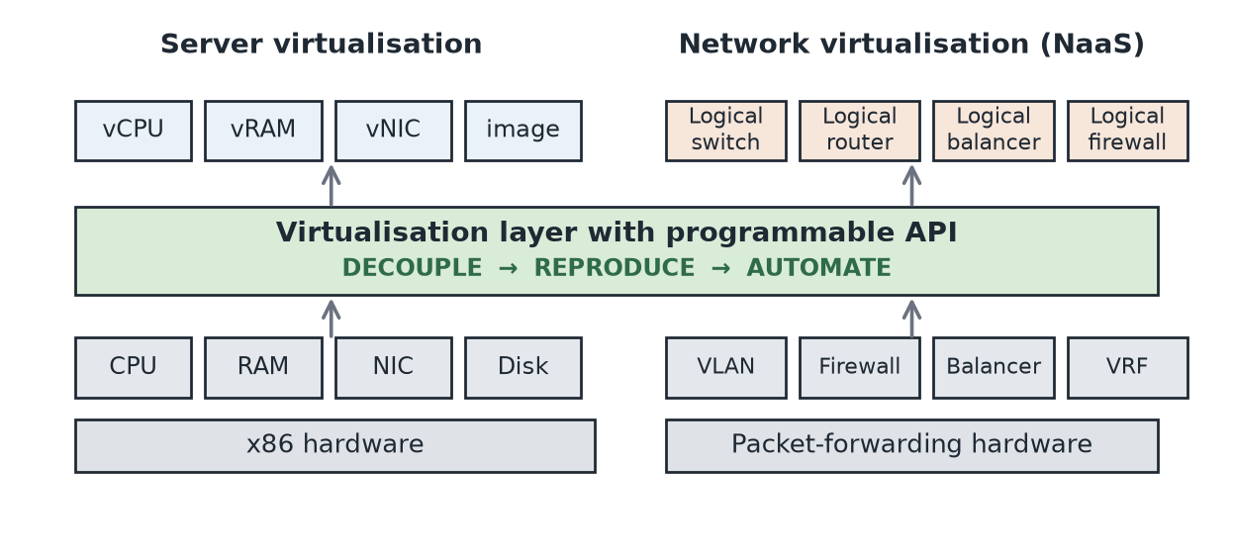
Figure 6. Network virtualisation applies to packet forwarding the same decoupling that server virtualisation applied to x86 hardware, reproducing switching, routing, load balancing and firewalling as software services above a programmable API. Adapted from Zhang (2026b) and VMware (2013).
Network as a Service is a cloud service category in which the capability provided to the cloud service customer is transport connectivity and related network capability (ISO/IEC 2014). Rather than buying, cabling and configuring switches, routers, load balancers and firewalls, the consumer requests network functions and connectivity on demand and pays for what is used — the same on-demand, self-service, measured model that IaaS applies to compute, applied to the network.
The enabling technology is network virtualisation. VMware (2013) characterises it as reproducing for the network what server virtualisation achieved for compute, through three steps: decouple the logical function from the physical hardware, reproduce that function in software, and automate its provisioning through an API. Where server virtualisation of x86 hardware produced the vCPU, vRAM, vNIC and machine image, network virtualisation of packet-forwarding hardware produces the logical switch, logical router, logical load balancer and logical firewall (Zhang 2026b). The practical consequence is that a complete multi-tier network topology, including its security policy, can be created, cloned or destroyed in software in the time it takes to run a script.
The building blocks are already visible in the virtualisation platform studied in this subject. A vSphere standard switch presents port groups that aggregate multiple ports under a common configuration and provide a stable anchor point for virtual machines connecting to labelled networks, with physical adapters mapped beneath (VMware 2011; Zhang 2026b). Because a VM is attached to a named port group rather than to a physical port, it keeps its network identity when it migrates — the same decoupling, expressed at the host level.
At the cloud level, NaaS extends beyond the data centre. Duan, Yan and Vasilakos (2012) survey its forms, which in current practice include virtual private cloud networks with tenant-defined address space, bandwidth and VPN connectivity on demand, load balancing and firewalling as metered services, and dedicated interconnect between an enterprise and a provider. Erl, Puttini and Mahmood's logical network perimeter mechanism — the isolation of a network from the rest of a communications network — is the security primitive underneath these offerings (Zhang 2026c). NaaS is best understood as a sibling of IaaS in the service-category taxonomy rather than a layer above or below it: it delivers network capability with the same self-service and metering properties that IaaS delivers compute capability.

7.2 Cloud ecosystems (5 points)
A cloud ecosystem is the interdependent set of actors, services and commercial relationships that surrounds a cloud platform, and through which value is delivered to a consumer. The point of the concept is that no single organisation supplies a complete cloud service: the consumer's experience is produced by a chain of specialised participants, each of which can be a different company.
The NIST reference architecture defines five major actors (Liu et al. 2011), and the subject material uses closely related terminology (Zhang 2026b):
Table 8. Actors in a cloud ecosystem (after Liu et al. 2011).
Actor | Role in the ecosystem
Cloud consumer | An organisation or person holding a formal contract with a provider to use IT resources the provider makes available; the party that actually derives business value.
Cloud provider | The company or third party that makes cloud services available — responsible for service deployment, orchestration, management, security and privacy.
Cloud carrier | Provides connectivity and transport of services between consumers and providers; without it the 'broad network access' characteristic cannot be met.
Cloud broker | Manages use, performance and delivery of cloud services and negotiates relationships between providers and consumers, adding value through service intermediation, aggregation or arbitrage.
Cloud auditor | Conducts independent assessment of services, operations, performance and security — the mechanism by which provider claims become verifiable to a consumer who cannot inspect the infrastructure.

Two further roles from the subject terminology refine the picture: the cloud service owner, the person or organisation that legally owns a cloud service, and the cloud resource administrator, responsible for administering cloud-based IT resources (Zhang 2026b). These matter because ownership, operation and consumption of a service are frequently held by three different parties — a SaaS vendor may own a service that runs on a second company's IaaS and is administered by a third company's managed-service team.
Beyond the actor model, three dynamics characterise a healthy ecosystem and explain why providers invest in building one:
- Complementarity and marketplaces. Independent software vendors, consultancies and managed-service partners build on the platform and distribute through its marketplace. Each addition increases the platform's value without cost to the provider.
- Standards and interoperability bodies. Shared vocabularies and interfaces — for example the ISO/IEC (2014) overview and vocabulary — let participants combine services from different providers, which is the precondition for brokerage and for hybrid architectures.
- Network effects and their downside. A larger ecosystem attracts more complements, which attracts more consumers. The same gravity produces switching costs, which is why lock-in (Question 6) is an ecosystem-level phenomenon and not merely an API-level one (Opara-Martins, Sahandi & Tian 2016).

Question 8 (10 points)
What is a data centre? List some basic components of a data centre.

8.1 What is a data centre? (5 points)
A data centre is a purpose-built facility that centralises an organisation's computing, storage and network equipment together with the power, cooling, physical security and connectivity infrastructure required to keep that equipment running continuously. It is best defined by function rather than by size: it is the place where IT resources are concentrated so that they can be operated, protected and shared more efficiently than if they were distributed.
Two features distinguish a data centre from a large server room. The first is engineered redundancy in the supporting infrastructure. The Uptime Institute (2018) Tier Classification System grades facilities from Tier I (basic capacity, single path, no redundancy) to Tier IV (fault-tolerant, multiple active distribution paths, concurrently maintainable), and TIA-942 specifies the corresponding cabling, spatial and infrastructure requirements (TIA 2017). The second is that the facility is engineered and operated as a single machine. Barroso, Clidaras and Hölzle (2013) argue that at cloud scale the building itself becomes the computer — a 'warehouse-scale computer' whose design objective is the efficiency of the facility as a whole, measured by metrics such as power usage effectiveness, rather than the performance of any individual server.
For cloud computing specifically, the data centre is the physical precondition of the entire model. Resource pooling requires resources to be physically co-located and densely interconnected; rapid elasticity requires spare capacity to be standing ready; measured service requires the metering infrastructure described in Question 3. Data centre technology is accordingly listed among the technology innovations underpinning the infrastructure of a cloud service provider (Zhang 2026c).

8.2 Basic components of a data centre (5 points)
The standard grouping divides the facility into four categories (Zhang 2026c; Erl, Puttini & Mahmood 2013):
Table 9. Basic components of a data centre grouped by category (after Zhang 2026c).
Category | Components
Facilities | Housing, racks, cabling, power supplies and the environmental control station — heating, ventilation, air conditioning, fire protection and other subsystems. In practice this also covers the power chain (utility feed, transformers, UPS, standby generators, power distribution units), hot- and cold-aisle containment, and physical access control.
Computing hardware | Servers and blade servers, typically commodity x86 machines aggregated into clusters and running a Type 1 hypervisor.
Storage hardware | Hard disk arrays, Storage Area Network (SAN) and Network-Attached Storage (NAS) systems, with the virtualisation layer described in Question 5 presenting them as pooled capacity.
Network hardware | Carrier and external network interconnection, web-tier load balancing and acceleration, LAN fabric, SAN fabric and NAS gateways.

A concrete instance of this structure is the physical topology of a VMware infrastructure data centre (VMware 2011; Zhang 2026b): a vCenter Server providing centralised management, accessed by vSphere clients and web clients; groups of physical servers each running ESX/ESXi and hosting virtual machines; and a fibre channel switch fabric or IP network connecting those hosts to fibre channel, iSCSI and NAS storage arrays. The mapping onto the four categories is direct — the server groups are the computing hardware, the arrays the storage hardware, the fabric the network hardware, and the racks, power and cooling that carry them the facilities.
One further component is easily overlooked but belongs in any complete list: the management and monitoring systems themselves. Data centre infrastructure management software, environmental sensors and the cloud usage monitors of Question 3 are what make the facility operable at scale, and their absence is felt long before any hardware fails.

References
Harvard (UTS) referencing style.
Armbrust, M., Fox, A., Griffith, R., Joseph, A.D., Katz, R., Konwinski, A., Lee, G., Patterson, D., Rabkin, A., Stoica, I. & Zaharia, M. 2010, 'A view of cloud computing', Communications of the ACM, vol. 53, no. 4, pp. 50–58.
Barham, P., Dragovic, B., Fraser, K., Hand, S., Harris, T., Ho, A., Neugebauer, R., Pratt, I. & Warfield, A. 2003, 'Xen and the art of virtualization', Proceedings of the 19th ACM Symposium on Operating Systems Principles (SOSP '03), ACM, New York, pp. 164–177.
Barroso, L.A., Clidaras, J. & Hölzle, U. 2013, The Datacenter as a Computer: An Introduction to the Design of Warehouse-Scale Machines, 2nd edn, Morgan & Claypool, San Rafael, CA.
Buyya, R., Yeo, C.S., Venugopal, S., Broberg, J. & Brandic, I. 2009, 'Cloud computing and emerging IT platforms: vision, hype, and reality for delivering computing as the 5th utility', Future Generation Computer Systems, vol. 25, no. 6, pp. 599–616.
Duan, Q., Yan, Y. & Vasilakos, A.V. 2012, 'A survey on service-oriented network virtualization toward convergence of networking and cloud computing', IEEE Transactions on Network and Service Management, vol. 9, no. 4, pp. 373–392.
Erl, T., Puttini, R. & Mahmood, Z. 2013, Cloud Computing: Concepts, Technology & Architecture, Prentice Hall, Upper Saddle River, NJ.
ISO/IEC 2014, ISO/IEC 17788:2014 Information technology — Cloud computing — Overview and vocabulary, International Organization for Standardization, Geneva.
Liu, F., Tong, J., Mao, J., Bohn, R., Messina, J., Badger, L. & Leaf, D. 2011, NIST Cloud Computing Reference Architecture, NIST Special Publication 500-292, National Institute of Standards and Technology, Gaithersburg, MD.
Marston, S., Li, Z., Bandyopadhyay, S., Zhang, J. & Ghalsasi, A. 2011, 'Cloud computing — the business perspective', Decision Support Systems, vol. 51, no. 1, pp. 176–189.
Mell, P. & Grance, T. 2011, The NIST Definition of Cloud Computing, NIST Special Publication 800-145, National Institute of Standards and Technology, Gaithersburg, MD.
Opara-Martins, J., Sahandi, R. & Tian, F. 2016, 'Critical analysis of vendor lock-in and its impact on cloud computing migration: a business perspective', Journal of Cloud Computing, vol. 5, no. 4, pp. 1–18.
Popek, G.J. & Goldberg, R.P. 1974, 'Formal requirements for virtualizable third generation architectures', Communications of the ACM, vol. 17, no. 7, pp. 412–421.
Ristenpart, T., Tromer, E., Shacham, H. & Savage, S. 2009, 'Hey, you, get off of my cloud: exploring information leakage in third-party compute clouds', Proceedings of the 16th ACM Conference on Computer and Communications Security (CCS '09), ACM, New York, pp. 199–212.
Tate, J., Beck, P., Ibarra, H.H., Kumaravel, S. & Miklas, L. 2018, Introduction to Storage Area Networks, IBM Redbooks SG24-5470-08, IBM Corporation, Poughkeepsie, NY.
Telecommunications Industry Association (TIA) 2017, TIA-942-B Telecommunications Infrastructure Standard for Data Centers, TIA, Arlington, VA.
Uptime Institute 2018, Tier Classification System, Uptime Institute, New York.
VMware 2009, VMware vSphere Basics: Storage Architecture, VMware Inc., Palo Alto, CA, viewed 27 August 2026, <http://pubs.vmware.com/vi3/intro/wwhelp/wwhimpl/common/html/wwhelp.htm>.
VMware 2011, VMware vSphere Basics: Network Architecture and Physical Topology of the VMware Infrastructure Data Center, VMware Inc., Palo Alto, CA, viewed 27 August 2026, <https://pubs.vmware.com/vsphere-50/>.
VMware 2013, VMware NSX Network Virtualization Platform, white paper, VMware Inc., Palo Alto, CA, viewed 27 August 2026, <https://www.vmware.com/content/dam/digitalmarketing/vmware/en/pdf/whitepaper/products/nsx/vmware-nsx-network-virtualization-platform-white-paper.pdf>.
Zhang, H. 2026a, Week 1: An Introduction, 41891/42891 Cloud Computing Infrastructures lecture notes, University of Technology Sydney, Sydney.
Zhang, H. 2026b, Week 2: Cloud Infrastructure Design — Virtualization Technologies, 41891/42891 Cloud Computing Infrastructures lecture notes, University of Technology Sydney, Sydney.
Zhang, H. 2026c, Week 3: Infrastructure/Management Mechanisms and Architectures, 41891/42891 Cloud Computing Infrastructures lecture notes, University of Technology Sydney, Sydney.
Zhang, H. 2026d, Week 2 Lab: VMware ESXi, Build VMs, 41891/42891 Cloud Computing Infrastructures lab guide, University of Technology Sydney, Sydney.
Zhang, H. 2026e, Week 6 Lab: Resources, 41891/42891 Cloud Computing Infrastructures lab guide, University of Technology Sydney, Sydney.
Zhang, H. 2026f, Week 4 Lab: vCenter Server and VM Migration, 41891/42891 Cloud Computing Infrastructures lab guide, University of Technology Sydney, Sydney.
Zhang, H. 2026g, Week 3 Lab: iSCSI (VMFS) on ESXi, 41891/42891 Cloud Computing Infrastructures lab guide, University of Technology Sydney, Sydney.
Zhang, Q., Cheng, L. & Boutaba, R. 2010, 'Cloud computing: state-of-the-art and research challenges', Journal of Internet Services and Applications, vol. 1, no. 1, pp. 7–18.

